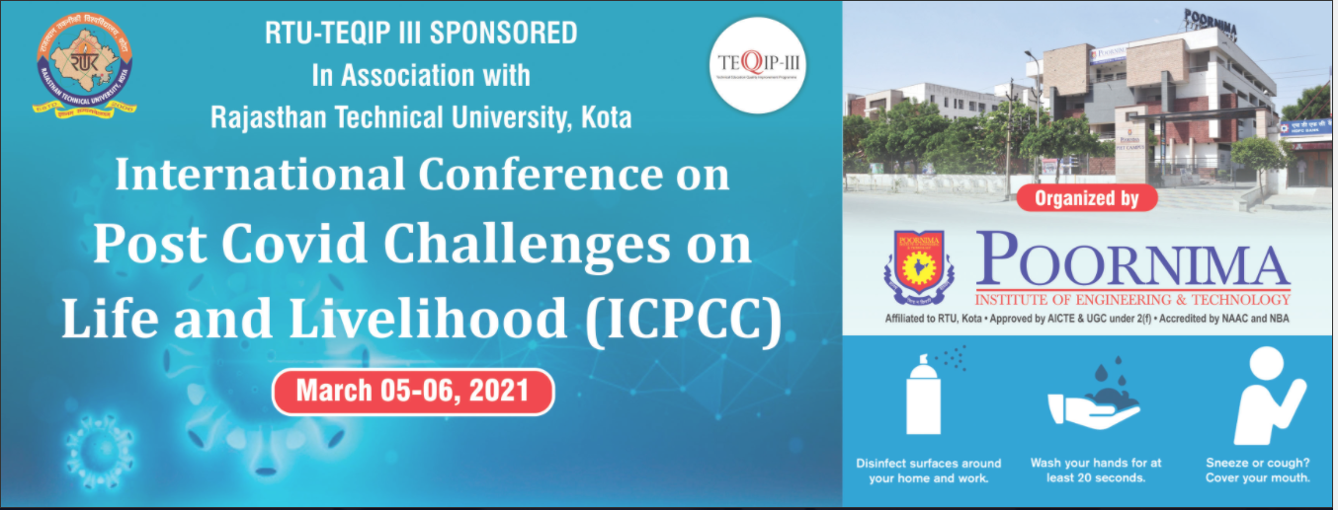

**_________________________________________________________________________________________________**

**Copyright Form**

I/We hereby certify that the materials used in manuscript of my research paper are my/ours' authentic work and any copyrighted material used for preparation of this manuscript has been duly acknowledged. I/We hereby assign the copyright of the paper to the technical committee of the ICPCC 2021 to publish my/ours' research paper in whatever form in the conference or any other journal which they deem fit. Any dispute that arises due to copyright infringement or plagiarism in respect of my/ours' research paper shall be borne by the author(s) only. The Organizing/Technical committee, ICPCC 2021 shall not be liable to any of the charges of copyright infringement or plagiarism against my/ours' paper.

I/We have carefully read this copyright form and understood the true meaning of it.

|  |  |
| --- | --- |
| Paper ID |  |
| Paper Title |  |

|  |  |
| --- | --- |
| Name of the Corresponding/  Presenting Author |  |
| Signature |  |
| Name of Co-Author(s) |  |
| Signature(s) |  |
| Date |  |

Note: This declaration may be signed by all authors or at least by one of the corresponding/presenting author.